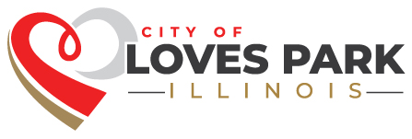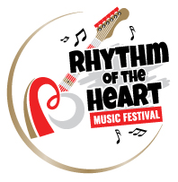

VOLUNTEER WAIVER

As a volunteer for the Rhythm of the Heart Music Festival on July 27th 2024, I recognize and acknowledge that there are certain risks of physical injury to volunteers participating in this activity, and I voluntarily agree to assume the full risk of any and all injuries, damages or loss, regardless of severity, that I may sustain as a result of said participation.

I further agree to forever waive, release and discharge the City of Loves Park, Illinois, its officers, and employees from any and all claims for injuries, damages, or loss that I may have arising out of, connected with, or in any way associated with my volunteer services.

I HAVE READ THIS RELEASE OF LIABILITY AND ASSUMPTION OF RISK AGREEMENT, FULLY UNDERSTAND ITS TERMS, AND SIGN IT FREELY AND VOLUNTARILY.

Name_________________________________________________________________

Signature_____________________________________________________________

Date__________________________________________________________________

